# Correlation (Pearson and Spearman’s Rank) and the chi-square test

Practice a Pearson correlation (this data was presented in the lecture).

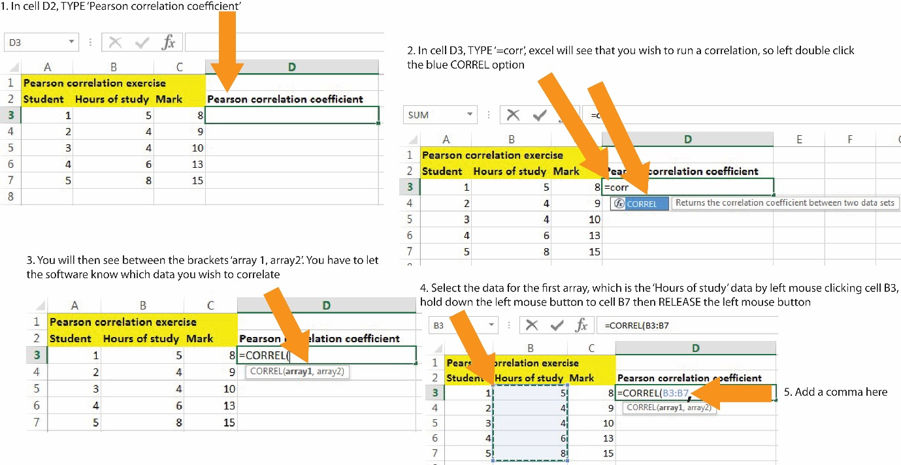

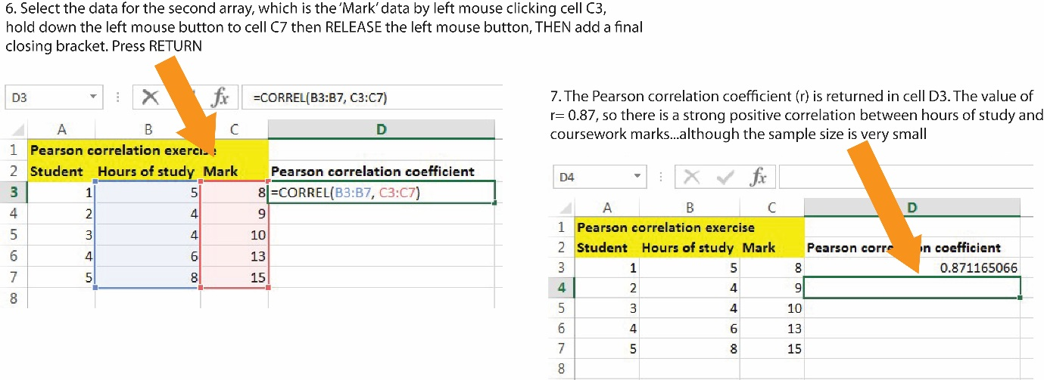

Have a go at the Spearman’s rank correlation (this data was also presented in the lecture).

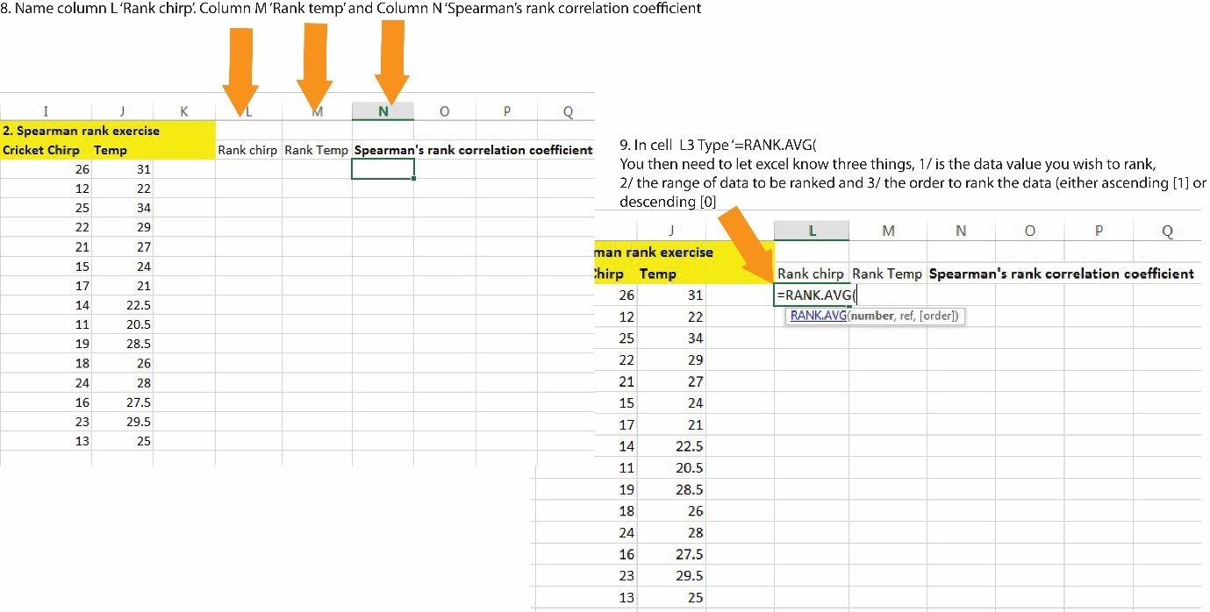

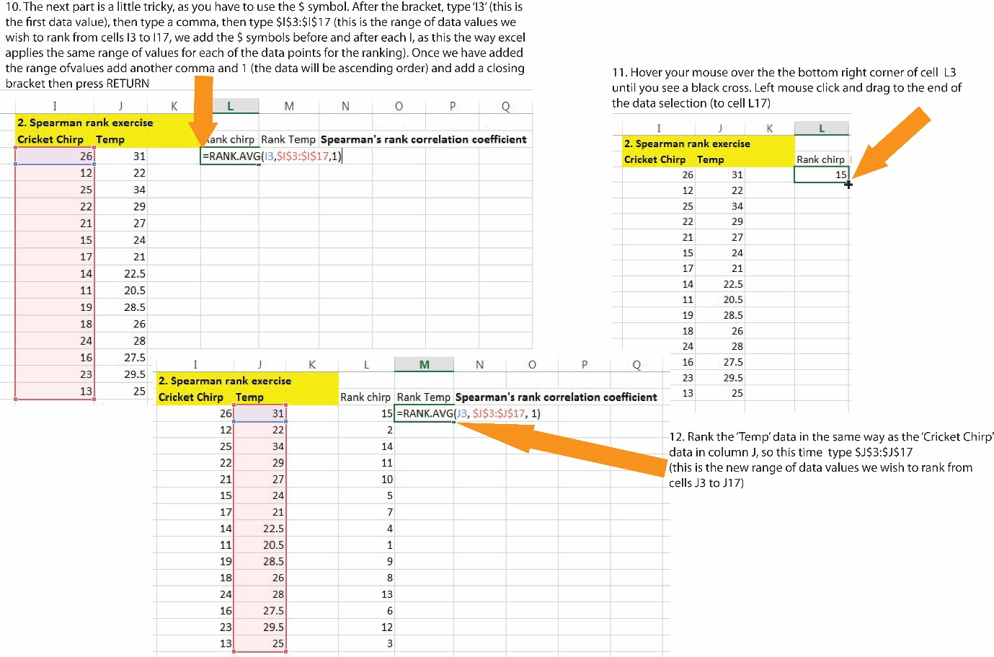

You are almost there! All you need to do now is to correlate the two columns of ranked data.

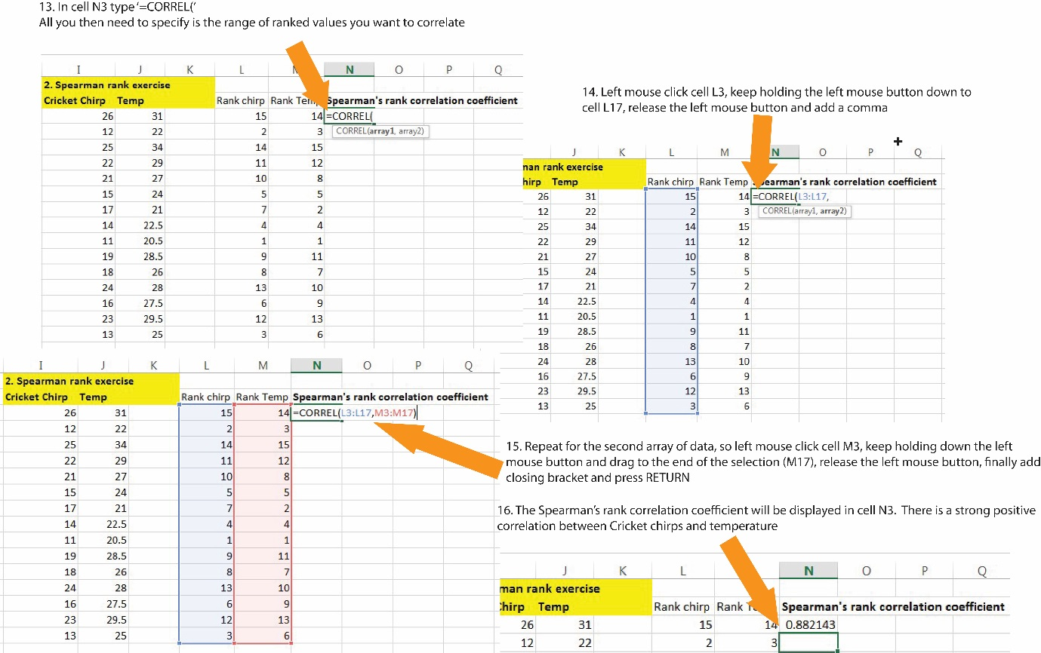

Finally have a go at calculating a chi-square (χ2) probability value for the ‘cats and dogs’ data using the ‘CHITEST’ function. Excel does not provide the χ2 value, but it does calculate the Chi Square probability or p-value. [P-values](http://www.statisticshowto.com/p-value/) are used in [hypothesis testing](http://www.statisticshowto.com/probability-and-statistics/hypothesis-testing/) to help you determine whether or not your results are [significant](http://www.statisticshowto.com/what-is-statistical-significance/) or not. A significant result is one where you reject the [null hypothesis](http://www.statisticshowto.com/what-is-the-null-hypothesis/).

